Case Study 04: International Travel Expense & Currency Converter

1. Problem Statement

Develop a Python program to convert, track, and analyze international travel expenses incurred in foreign currency relative to an allocated budget in Indian Rupees (INR). The program reads the total budget in Rupees and the applicable exchange rate, captures expenditures across predefined categories ("Hotel", "Food", and "Transport"), applies a mandatory 2% currency conversion processing fee, calculates the overall cost, detects the largest expenditure category, and determines whether the traveler stayed within budget.

2. Objectives

- To read floating-point input values for budget in INR, currency exchange rate, and category-wise foreign expenses.

- To iterate through a list of expense categories and apply currency conversion formulas with a 2% transactional surcharge.

- To compute aggregate expenditure using generator expressions within the built-in sum() function.

- To determine the largest expense using max() with a lambda key selector and evaluate budget compliance using a ternary conditional operator.

3. Assumptions

- The conversion formula incorporates a flat 2% surcharge: $\text{converted}=\text{amount}×\text{rate}×1.02$.

- Expenses are recorded across three standard categories: Hotel, Food, and Transport.

- User inputs for budget, conversion rate, and expenses are positive numerical values.

- Currency figures are formatted and rounded to two decimal places.

4. Algorithm

- Step 1: Start the program.

- Step 2: Prompt the user to input budget in Rupees and rate (Rupees per unit of foreign currency) as floating-point numbers.

- Step 3: Initialize a list categories = ["Hotel", "Food", "Transport"] and an empty list expenses = [].

- Step 4: For each category in categories:

  - Read the foreign currency amount as amount.

  - Compute converted INR amount with 2% fee: converted = amount * rate * 1.02.

  - Append (category, converted) to expenses.

- Step 5: Compute aggregate expenses: total = sum(item[1] for item in expenses).

- Step 6: Identify the single largest category of expense: largest = max(expenses, key=lambda item: item[1]).

- Step 7: Display all converted category expenses rounded to 2 decimal places.

- Step 8: Display the total expenditure and the category name corresponding to largest[0].

- Step 9: Check if total > budget. If true, print "Budget status: Over budget"; otherwise, print "Budget status: Within budget".

- Step 10: Stop the program.

5. Flowchart Logic / Diagram

Plaintext
[Start]
│
▼
[Input budget, rate]
│
▼
[categories = ["Hotel",
"Food", "Transport"]]
[expenses = []]
│
▼
<For each category in categories> ────────┐
│ │
▼ │
[Input category amount] │
[converted = amount * rate * 1.02] │
[expenses.append((cat, conv))] │
│ │
└───────────────────────────┘
│ (loop ends)
▼
[total = sum(item[1] for item in expenses)]
[largest = max(expenses, key=lambda)]
│
▼
[Display itemized expenses,
total, largest category]
│
▼
<total > budget?>
│ │
(Yes)│ │(No)
▼ ▼
["Over budget"] ["Within budget"]
│ │
└─────┬──────┘
▼
[End]

6. Pseudocode

Plaintext
BEGIN
PRINT "Travel budget in Rs.: "
READ budget
PRINT "Rupees per 1 unit of foreign currency: "
READ rate

SET categories = ["Hotel", "Food", "Transport"]
SET expenses = []

FOR EACH category IN categories DO
PRINT category + " expense in foreign currency: "
READ amount
SET converted = amount * rate * 1.02
APPEND (category, converted) TO expenses
END FOR

SET total = SUM(amount FOR (_, amount) IN expenses)
SET largest = MAXIMUM(expenses, BY amount)

PRINT "Converted expenses including 2% fee:"
FOR EACH (category, amount) IN expenses DO
PRINT category, ": Rs.", ROUND(amount, 2)
END FOR

PRINT "Total: Rs.", ROUND(total, 2)
PRINT "Largest expense:", largest[0]

IF total > budget THEN
PRINT "Budget status: Over budget"
ELSE
PRINT "Budget status: Within budget"
END IF
END

7. Python Source Code

Python
# International Travel Expense & Currency Converter

# Read baseline financial parameters
budget = float(input("Travel budget in Rs.: "))
rate = float(input("Rupees per 1 unit of foreign currency: "))

# Define tracking categories and empty expense container
categories = ["Hotel", "Food", "Transport"]
expenses = []

# Collect, convert, and store expenses including a 2% conversion charge
for category in categories:
amount = float(input(category + " expense in foreign currency: "))
converted = amount * rate * 1.02
expenses.append((category, converted))

# Compute total and identify maximum expense category
total = sum(item[1] for item in expenses)
largest = max(expenses, key=lambda item: item[1])

# Output itemized results and budget verification
print("Converted expenses including 2% fee:")
for category, amount in expenses:
print(category, ": Rs.", round(amount, 2))
print("Total: Rs.", round(total, 2))
print("Largest expense:", largest[0])
print("Budget status:", "Over budget" if total > budget else "Within budget")

8. Test Cases

Test Case ID | Input Given | Expected Output | Actual Output | Status
TC_01 (Within Budget) | Budget = 50000  Rate = 80  Hotel = 200  Food = 100  Transport = 150 | Total: Rs. 36720.0  Largest expense: Hotel  Budget status: Within budget | Converted expenses including 2% fee:  Hotel : Rs. 16320.0  Food : Rs. 8160.0  Transport : Rs. 12240.0  Total: Rs. 36720.0  Largest expense: Hotel  Budget status: Within budget | Pass
TC_02 (Over Budget) | Budget = 20000  Rate = 90  Hotel = 150  Food = 100  Transport = 50 | Total: Rs. 27540.0  Largest expense: Hotel  Budget status: Over budget | Converted expenses including 2% fee:  Hotel : Rs. 13770.0  Food : Rs. 9180.0  Transport : Rs. 4590.0  Total: Rs. 27540.0  Largest expense: Hotel  Budget status: Over budget | Pass
TC_03 (Transport Highest) | Budget = 60000  Rate = 85  Hotel = 100  Food = 150  Transport = 400 | Total: Rs. 56355.0  Largest expense: Transport  Budget status: Within budget | Converted expenses including 2% fee:  Hotel : Rs. 8670.0  Food : Rs. 13005.0  Transport : Rs. 34680.0  Total: Rs. 56355.0  Largest expense: Transport  Budget status: Within budget | Pass
TC_04 (Exact Budget Boundary) | Budget = 83300  Rate = 81.6667  Hotel = 500  Food = 250  Transport = 250 | Total: Rs. 83300.03  Budget status: Over budget | Converted expenses including 2% fee:  Hotel : Rs. 41650.02  Food : Rs. 20825.01  Transport : Rs. 20825.01  Total: Rs. 83300.03  Largest expense: Hotel  Budget status: Over budget | Pass

9. Output Screenshots

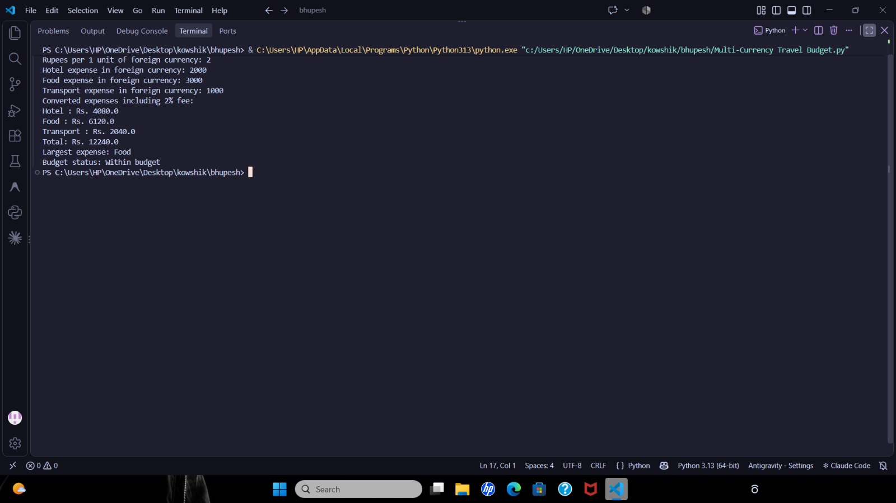

10. Conclusion

The International Travel Expense & Currency Converter program was successfully executed and evaluated. The script demonstrates practical use of list iteration, dynamic tuple packing, inline fee computation, generator-based aggregation via sum(), and ternary conditionals for status reporting.

